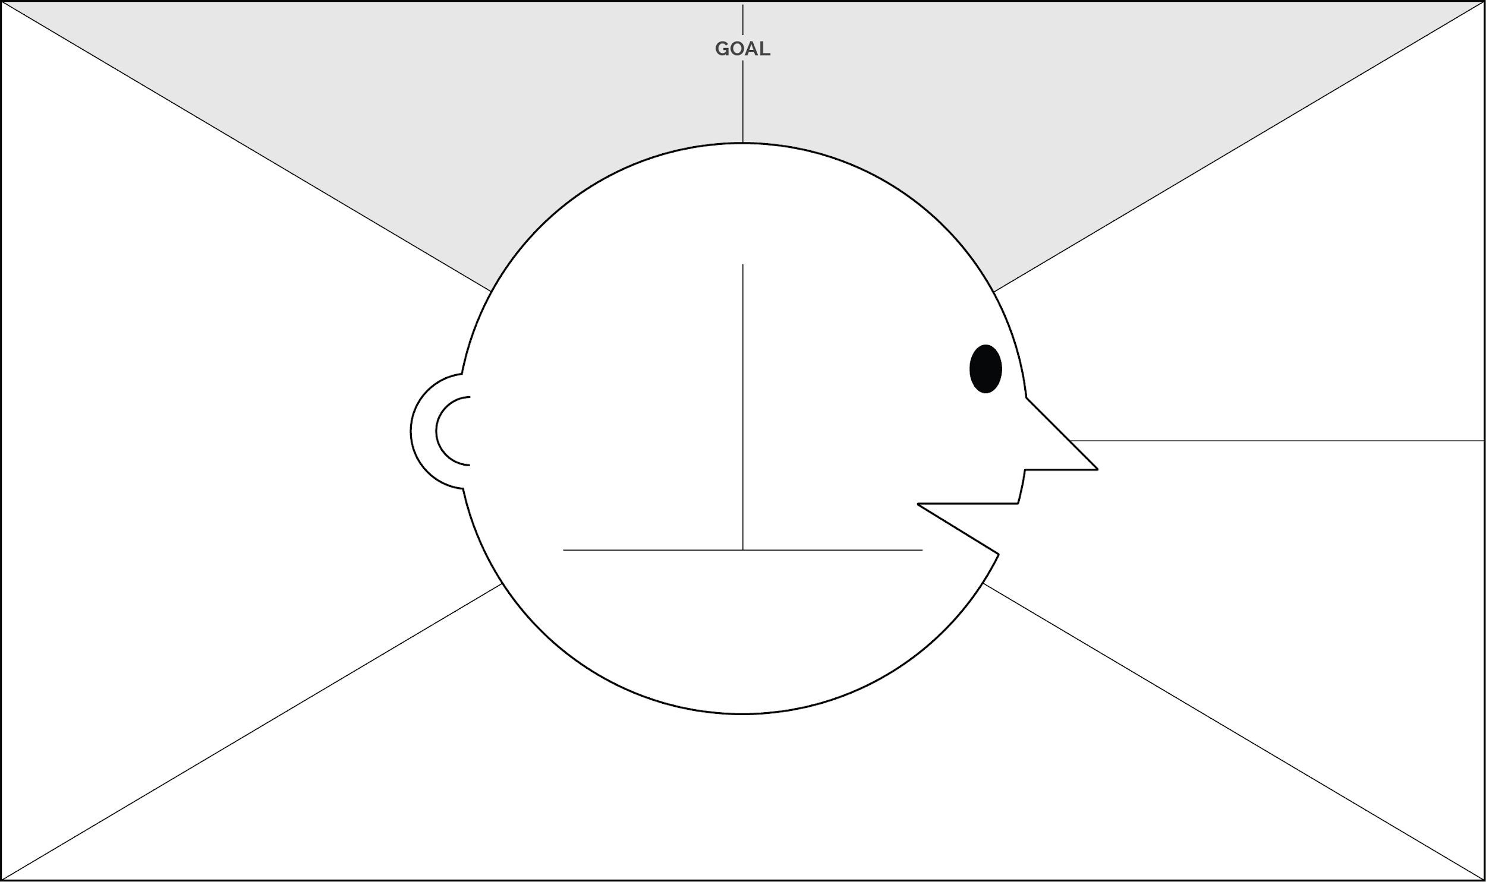

1 WHO are we empathising with?
They empathise with the plastic pollution problem in the country.

2 What do they need to DO?
- They should be aware/conscious about their litter disposal behaviours.
- They should use less plastics in their day-to-day life.
- They should use alternative products that use less products.

6 What do they THINK and FEEL?

6 What do they HEAR?
- They encounter information on pollution reduction in digital/ mass media.

PAINS
They are uncertain about life in event that plastic use is limited.

GAINS
They express optimism that reduced use of plastic pollution positively impacts nature.

What do they SEE?
- They encounter the plastic pollution at workplaces and other areas.
- They see efforts being made to reduce plastic pollution.

What do they SAY?

Office Workers express genuine interest in plastic pollution
and communicate optimism to reduce plastic use in their workplaces.
  - They want to take part in efforts to reduce plastic pollution.
  - At the workplace, there are no aggressive strategies to reduce plastic pollution

5. What do they DO?
- They use plastics a lot in the day-to-day living.
- They are unaware of how they can be supported towards reduction plastic use.

